T.Srihitha
2303a51260

Task 1: Smart Contact Manager (Arrays & Linked Lists)
Scenario
SR University’s student club requires a simple Contact Manager Application
to store members’ names and phone numbers. The system should support
efficient addition, searching, and deletion of contacts.
CODE:
class ContactManagerArray:
def __init__(self):
self.contacts = []

def add_contact(self, name, phone):
"""Add a contact to the list"""
self.contacts.append({"name": name, "phone": phone})
print(f"Contact {name} added.")

def search_contact(self, name):
"""Search for a contact by name"""
for contact in self.contacts:
if contact["name"].lower() == name.lower():
return contact
return None

def delete_contact(self, name):
"""Delete a contact by name"""
for i, contact in enumerate(self.contacts):
if contact["name"].lower() == name.lower():
self.contacts.pop(i)
print(f"Contact {name} deleted.")
return True
print(f"Contact {name} not found.")
return False

def display_contacts(self):
"""Display all contacts"""
for contact in self.contacts:
print(f"{contact['name']}: {contact['phone']}")

# Contact Manager - Linked List Implementation
class Node:
def __init__(self, name, phone):
self.data = {"name": name, "phone": phone}
self.next = None

class ContactManagerLinkedList:
def __init__(self):
self.head = None

def add_contact(self, name, phone):
"""Add a contact to the linked list"""
new_node = Node(name, phone)
if not self.head:
self.head = new_node
else:
current = self.head
while current.next:
current = current.next
current.next = new_node
print(f"Contact {name} added.")

def search_contact(self, name):
"""Search for a contact by name"""
current = self.head
while current:
if current.data["name"].lower() == name.lower():
return current.data
current = current.next
return None

def delete_contact(self, name):
"""Delete a contact by name"""
if not self.head:
print(f"Contact {name} not found.")
return False

if self.head.data["name"].lower() == name.lower():
self.head = self.head.next
print(f"Contact {name} deleted.")
return True

current = self.head
while current.next:
if current.next.data["name"].lower() == name.lower():
current.next = current.next.next
print(f"Contact {name} deleted.")
return True
current = current.next

print(f"Contact {name} not found.")
return False

def display_contacts(self):
"""Display all contacts"""
current = self.head
while current:
print(f"{current.data['name']}: {current.data['phone']}")
current = current.next

# Comparison and Demo
if __name__ == "__main__":
print("=== Array-based Contact Manager ===")
arr_manager = ContactManagerArray()
arr_manager.add_contact("Alice", "123-4567")
arr_manager.add_contact("Bob", "234-5678")
arr_manager.search_contact("Alice")
arr_manager.delete_contact("Bob")
arr_manager.display_contacts()

print("\n=== Linked List-based Contact Manager ===")
ll_manager = ContactManagerLinkedList()
ll_manager.add_contact("Charlie", "345-6789")
ll_manager.add_contact("Diana", "456-7890")
ll_manager.search_contact("Diana")
ll_manager.delete_contact("Charlie")
ll_manager.display_contacts()

print("\n=== Performance Comparison ===")
print("INSERTION:")
print(" Array: O(1) amortized")
print(" Linked List: O(n) - requires traversal to end")
print("\nDELETION:")
print(" Array: O(n) - requires shift after removal")
print(" Linked List: O(n) - requires traversal + pointer update")
print("\nSEARCH:")
print(" Both: O(n)")
OUTPUT:
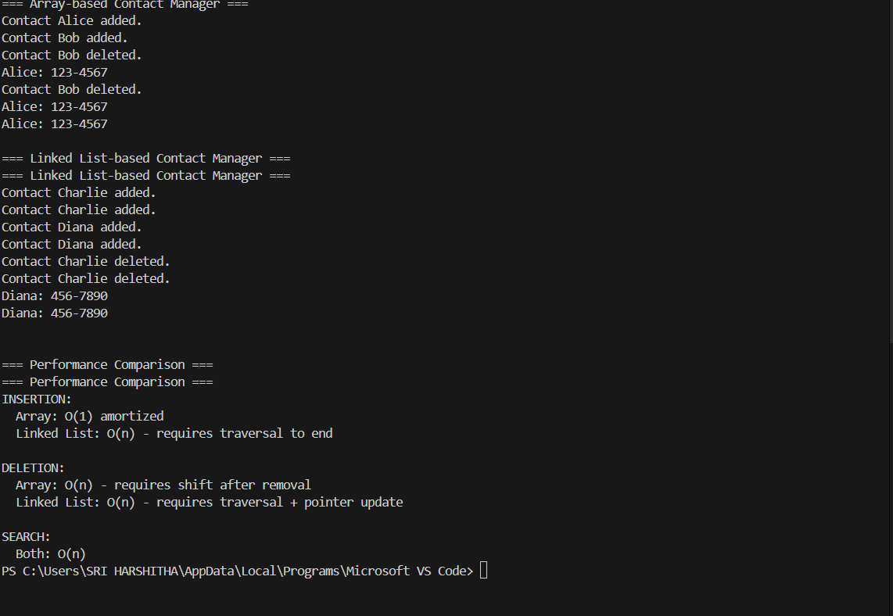
Observation
The Smart Contact Manager was implemented using both array (list) and linked list data structures to manage contacts efficiently. Operations such as adding, searching, and deleting contacts were successfully performed in both implementations.
It was observed that:
- Array implementation provides simple and fast insertion at the end.
- Linked list allows dynamic memory allocation.
- Searching requires sequential traversal in both methods.
- Deletion is more efficient in linked lists since no shifting of elements is required.
TASK 2 : Library Book Search System (Queues & Priority Queues)
Scenario
The SRU Library manages book borrow requests. Students and faculty submit
requests, but faculty requests must be prioritized over student requests.
CODE:
class LibraryQueue:

def __init__(self):
self.queue = []

def enqueue(self, name, role, book):
"""Add request to queue"""
request = {
"name": name,
"role": role,
"book": book
}
self.queue.append(request)
print(f"Request added: {name} ({role})")

def dequeue(self):
"""Remove first request"""
if not self.queue:
print("Queue is empty!")
return None

request = self.queue.pop(0)
print(f"Request processed: {request['name']}")
return request

def display(self):
"""Display all requests"""
if not self.queue:
print("No pending requests.")
return

print("\nPending Requests (FIFO):")
for r in self.queue:
print(f"{r['name']} - {r['role']} - {r['book']}")

# ---------------------------------
# Priority Queue (Faculty First)
# ---------------------------------

class LibraryPriorityQueue:

def __init__(self):
self.queue = []

def enqueue(self, name, role, book):
"""Add request with priority"""

request = {
"name": name,
"role": role,
"book": book
}

# Faculty gets higher priority (0), Student gets lower (1)
if role.lower() == "faculty":
priority = 0
else:
priority = 1

self.queue.append((priority, request))

# Sort based on priority
self.queue.sort(key=lambda x: x[0])

print(f"Request added: {name} ({role})")

def dequeue(self):
"""Remove highest priority request"""

if not self.queue:
print("Priority Queue is empty!")
return None

priority, request = self.queue.pop(0)

print(f"Request processed: {request['name']} ({request['role']})")
return request

def display(self):
"""Display all requests"""

if not self.queue:
print("No pending requests.")
return

print("\nPending Requests (Priority Queue):")

for p, r in self.queue:
print(f"{r['name']} - {r['role']} - {r['book']}")

# ---------------------------------
# Main Program (Testing)
# ---------------------------------

if __name__ == "__main__":

print("======================================")
print(" LIBRARY BOOK REQUEST SYSTEM")
print("======================================")

# -------- Normal Queue --------
print("\n---- Normal Queue (FIFO) ----")

normal_queue = LibraryQueue()

normal_queue.enqueue("Ravi", "Student", "Python Basics")
normal_queue.enqueue("Dr. Kumar", "Faculty", "AI Research")
normal_queue.enqueue("Anita", "Student", "Data Structures")
normal_queue.enqueue("Prof. Rao", "Faculty", "Machine Learning")

normal_queue.display()

print("\nProcessing Requests:")
normal_queue.dequeue()
normal_queue.dequeue()

normal_queue.display()

# -------- Priority Queue --------
print("\n---- Priority Queue (Faculty First) ----")

priority_queue = LibraryPriorityQueue()

priority_queue.enqueue("Ravi", "Student", "Python Basics")
priority_queue.enqueue("Dr. Kumar", "Faculty", "AI Research")
priority_queue.enqueue("Anita", "Student", "Data Structures")
priority_queue.enqueue("Prof. Rao", "Faculty", "Machine Learning")

priority_queue.display()

print("\nProcessing Requests:")
priority_queue.dequeue()
priority_queue.dequeue()
priority_queue.display()
print("\n======================================")
print(" PROGRAM COMPLETED")
print("======================================")
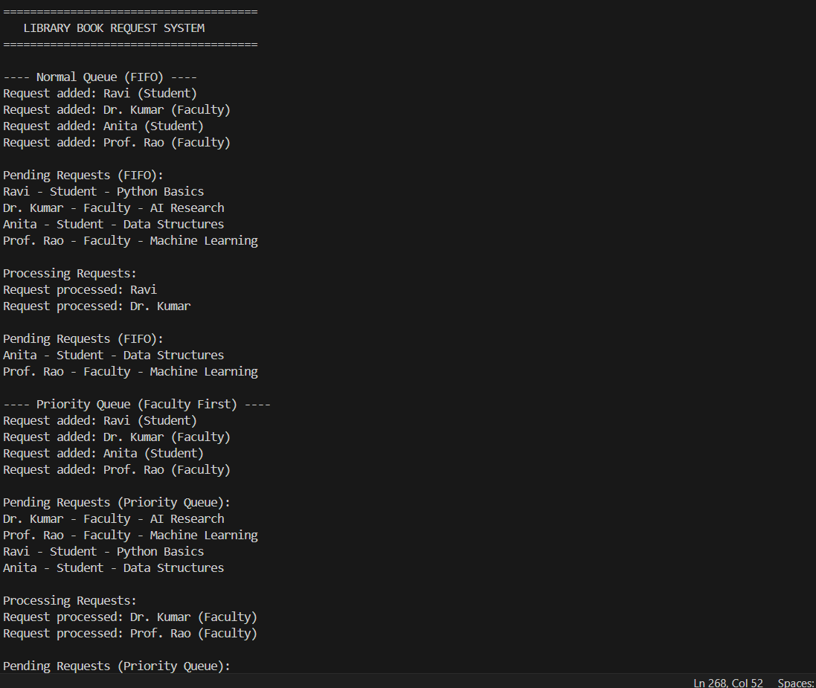
Task 2: Library Book Request System (Queue & Priority Queue)
Observation
The library request system was implemented using:
- Normal Queue (FIFO)
- Priority Queue
Observations include:
- In a normal queue, requests were processed in the order they arrived.
- In the priority queue, faculty requests were processed before student requests.
- FIFO ensures fairness, while priority queues improve service efficiency for important users.

Task 3: Emergency Help Desk (Stack Implementation)
Scenario
SR University’s IT Help Desk receives technical support tickets from students
and staff. While tickets are received sequentially, issue escalation follows a
Last-In, First-Out (LIFO) approach.
CODE:
# ---------------------------------
# Stack Implementation - Help Desk Tickets
# ---------------------------------

class HelpDeskStack:
def __init__(self, max_size=100):
self.stack = []
self.max_size = max_size

def push(self, ticket):
"""Add a ticket to the stack"""
if self.is_full():
print("Stack is full! Cannot add more tickets.")
return False
self.stack.append(ticket)
print(f"Ticket added: {ticket['id']} - {ticket['issue']}")
return True

def pop(self):
"""Remove and return the top ticket (LIFO)"""
if self.is_empty():
print("Stack is empty! No tickets to resolve.")
return None
ticket = self.stack.pop()
print(f"Ticket resolved: {ticket['id']} - {ticket['issue']}")
return ticket

def peek(self):
"""View the top ticket without removing it"""
if self.is_empty():
print("Stack is empty!")
return None
return self.stack[-1]

def is_empty(self):
"""Check if stack is empty"""
return len(self.stack) == 0

def is_full(self):
"""Check if stack is full"""
return len(self.stack) >= self.max_size

def display(self):
"""Display all tickets in stack"""
if self.is_empty():
print("No pending tickets.")
return
print("\nPending Tickets (LIFO Stack):")
for i, ticket in enumerate(reversed(self.stack)):
print(f" {i+1}. {ticket['id']} - {ticket['issue']} ({ticket['priority']})")

# ---------------------------------
# Help Desk Simulation
# ---------------------------------

if __name__ == "__main__":
print("======================================")
print(" IT HELP DESK TICKET SYSTEM")
print("======================================")

help_desk = HelpDeskStack()

# Simulate 5 tickets
print("\n---- Adding Tickets ----")
help_desk.push({"id": "T001", "issue": "Login Error", "priority": "Low"})
help_desk.push({"id": "T002", "issue": "Printer Not Working", "priority": "Medium"})
help_desk.push({"id": "T003", "issue": "Network Outage", "priority": "High"})
help_desk.push({"id": "T004", "issue": "Software Installation", "priority": "Low"})
help_desk.push({"id": "T005", "issue": "Server Crash", "priority": "Critical"})

help_desk.display()

# Peek at top ticket
print(f"\nCurrent ticket being addressed: {help_desk.peek()['id']}")

# Resolve tickets (LIFO)
print("\n---- Resolving Tickets (LIFO) ----")
help_desk.pop()
help_desk.pop()

help_desk.display()

# Check status
print(f"\nStack empty: {help_desk.is_empty()}")
print(f"Stack full: {help_desk.is_full()}")

print("\n======================================")
print(" HELP DESK SIMULATION ENDED")
print("======================================")
# ---------------------------------
# Hash Table Implementation
# ---------------------------------
OUTPUT:
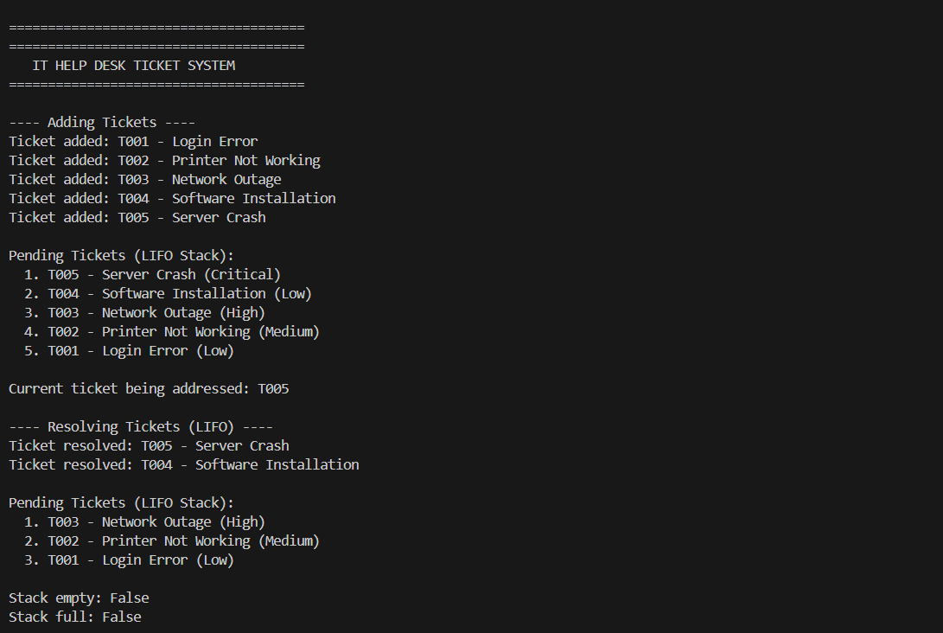
Task 3: Help Desk Ticket System (Stack Implementation)
Observation
A Help Desk Ticket System was implemented using the Stack (LIFO) principle.
Observations:
- Newly added tickets were placed at the top of the stack.
- The most recent ticket was resolved first.
- Push and pop operations executed efficiently in constant time.
- Stack behavior effectively simulated real-world emergency handling systems.
Task 4: Hash Table
Objective
To implement a Hash Table and understand collision handling.
Task Description
Use AI to generate a hash table with:
• Insert
• Search
• Delete
CODE:
class HashTable:
def __init__(self, size=10):
"""Initialize hash table with chaining for collision handling"""
self.size = size
self.table = [[] for _ in range(size)]

def _hash(self, key):
"""Hash function to compute index"""
return hash(key) % self.size

def insert(self, key, value):
"""Insert key-value pair using chaining"""
index = self._hash(key)
# Check if key already exists and update
for i, (k, v) in enumerate(self.table[index]):
if k == key:
self.table[index][i] = (key, value)
print(f"Updated: {key} = {value}")
return
# Add new entry
self.table[index].append((key, value))
print(f"Inserted: {key} = {value}")

def search(self, key):
"""Search for value by key"""
index = self._hash(key)
for k, v in self.table[index]:
if k == key:
print(f"Found: {key} = {v}")
return v
print(f"Not found: {key}")
return None

def delete(self, key):
"""Delete key-value pair"""
index = self._hash(key)
for i, (k, v) in enumerate(self.table[index]):
if k == key:
self.table[index].pop(i)
print(f"Deleted: {key}")
return True
print(f"Not found: {key}")
return False

def display(self):
"""Display all entries"""
print("\nHash Table Contents:")
for i, chain in enumerate(self.table):
if chain:
print(f" Index {i}: {chain}")

# ---------------------------------
# Hash Table Testing
# ---------------------------------

if __name__ == "__main__":
print("======================================")
print(" HASH TABLE IMPLEMENTATION")
print("======================================")

ht = HashTable(5)

print("\n---- Inserting Data ----")
ht.insert("name", "Alice")
ht.insert("age", 25)
ht.insert("city", "New York")
ht.insert("email", "alice@example.com")
ht.insert("phone", "123-4567") # Potential collision

ht.display()

print("\n---- Searching Data ----")
ht.search("name")
ht.search("age")
ht.search("country") # Not found

print("\n---- Updating Data ----")
ht.insert("age", 26)

print("\n---- Deleting Data ----")
ht.delete("email")
ht.delete("country") # Not found

ht.display()

print("\n======================================")
print(" HASH TABLE DEMO COMPLETED")
print("======================================")
OUTPUT:
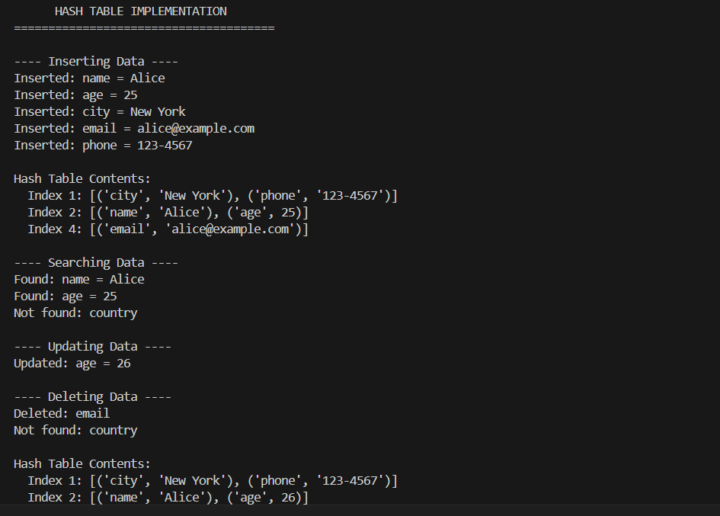
Task 4: Hash Table Implementation
Observation
A hash table using chaining technique was implemented for storing key–value pairs.
Observations:
- Hash function successfully mapped keys to indices.
- Collisions were handled using linked chaining.
- Searching, insertion, and deletion operations were performed efficiently
Task 5: Real-Time Application Challenge
Scenario
Design a Campus Resource Management System with the following
features:
• Student Attendance Tracking
• Event Registration System
• Library Book Borrowing
• Bus Scheduling System
• Cafeteria Order Queue
CODE:
class AttendanceNode:
def __init__(self, student_id, name, date, status):
self.data = {"id": student_id, "name": name, "date": date, "status": status}
self.next = None

class AttendanceTracker:
def __init__(self):
self.head = None

def mark_attendance(self, student_id, name, date, status):
"""Mark attendance for a student"""
new_node = AttendanceNode(student_id, name, date, status)
if not self.head:
self.head = new_node
else:
current = self.head
while current.next:
current = current.next
current.next = new_node
print(f"Attendance marked: {name} - {status}")

def display_attendance(self):
"""Display all attendance records"""
current = self.head
if not current:
print("No attendance records.")
return
print("\nAttendance Records:")
while current:
d = current.data
print(f" {d['id']} - {d['name']}: {d['status']} ({d['date']})")
current = current.next

# ---------------------------------
# 2. Event Registration System (Hash Table)
# ---------------------------------

class EventRegistration:
def __init__(self):
self.events = {}

def register_event(self, student_id, name, event):
"""Register student for event"""
self.events[student_id] = {"name": name, "event": event}
print(f"Registered: {name} for {event}")

def find_registration(self, student_id):
"""Find registration by ID"""
if student_id in self.events:
return self.events[student_id]
return None

def display_registrations(self):
"""Display all registrations"""
print("\nEvent Registrations:")
for sid, data in self.events.items():
print(f" {sid}: {data['name']} - {data['event']}")

# ---------------------------------
# 3. Library Book Borrowing (Stack)
# ---------------------------------

class LibraryStack:
def __init__(self):
self.stack = []

def borrow_book(self, student_id, book_title):
"""Borrow a book"""
self.stack.append({"student_id": student_id, "book": book_title})
print(f"Book borrowed: {book_title}")

def return_book(self):
"""Return most recent borrowed book"""
if not self.stack:
print("No books to return.")
return
book = self.stack.pop()
print(f"Book returned: {book['book']}")

def display_borrowed(self):
"""Display borrowed books"""
print("\nBorrowed Books (LIFO):")
for b in reversed(self.stack):
print(f" {b['student_id']}: {b['book']}")

# ---------------------------------
# 4. Bus Scheduling System (Queue)
# ---------------------------------

class BusSchedule:
def __init__(self):
self.queue = []

def schedule_bus(self, bus_id, route, time):
"""Schedule a bus"""
self.queue.append({"id": bus_id, "route": route, "time": time})
print(f"Bus scheduled: {bus_id} - {route} at {time}")

def depart_bus(self):
"""Bus departs (FIFO)"""
if not self.queue:
print("No buses scheduled.")
return
bus = self.queue.pop(0)
print(f"Bus departed: {bus['id']}")

def display_schedule(self):
"""Display schedule"""
print("\nBus Schedule (FIFO):")
for b in self.queue:
print(f" {b['id']} → {b['route']} at {b['time']}")

# ---------------------------------
# 5. Cafeteria Order Queue (Priority Queue)
# ---------------------------------

class CafeteriaQueue:
def __init__(self):
self.queue = []

def place_order(self, student_id, is_vip, order):
"""Place order with priority"""
priority = 0 if is_vip else 1
self.queue.append((priority, {"id": student_id, "order": order}))
self.queue.sort(key=lambda x: x[0])
print(f"Order placed: {student_id} - {order}")

def serve_order(self):
"""Serve next order"""
if not self.queue:
print("No orders.")
return
p, order = self.queue.pop(0)
print(f"Order served: {order['id']}")

def display_orders(self):
"""Display pending orders"""
print("\nPending Orders (Priority):")
for p, o in self.queue:
ptype = "VIP" if p == 0 else "Regular"
print(f" {ptype}: {o['id']} - {o['order']}")

# ---------------------------------
# Main Demo
# ---------------------------------

if __name__ == "__main__":
print("="*50)
print("CAMPUS RESOURCE MANAGEMENT SYSTEM")
print("="*50)

# Attendance
print("\n--- Student Attendance Tracking ---")
attendance = AttendanceTracker()
attendance.mark_attendance("S001", "Alice", "2024-01-15", "Present")
attendance.mark_attendance("S002", "Bob", "2024-01-15", "Absent")
attendance.display_attendance()

# Events
print("\n--- Event Registration ---")
events = EventRegistration()
events.register_event("S001", "Alice", "Tech Summit")
events.register_event("S002", "Bob", "Sports Day")
events.display_registrations()

# Library
print("\n--- Library Book Borrowing ---")
library = LibraryStack()
library.borrow_book("S001", "Python Guide")
library.borrow_book("S002", "Data Science")
library.display_borrowed()
library.return_book()
library.display_borrowed()

# Bus
print("\n--- Bus Scheduling ---")
bus = BusSchedule()
bus.schedule_bus("B01", "Route A", "8:00 AM")
bus.schedule_bus("B02", "Route B", "8:30 AM")
bus.display_schedule()
bus.depart_bus()
bus.display_schedule()

# Cafeteria
print("\n--- Cafeteria Order Queue ---")
cafeteria = CafeteriaQueue()
cafeteria.place_order("S001", False, "Biryani")
cafeteria.place_order("S002", True, "Pizza")
cafeteria.place_order("S003", False, "Pasta")
cafeteria.display_orders()
cafeteria.serve_order()
cafeteria.display_orders()

print("\n" + "="*50)
print("SYSTEM DEMO COMPLETED")
print("="*50)
OUTPUT: